* - A file not under version control. These are typically new files that you have not committed to the repository yet.  
  Synchronized File - A file with no local changes.

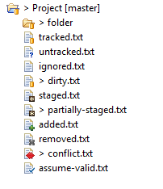

<https://stackoverflow.com/questions/15556550/need-help-understanding-the-git-icons-in-eclipse>

That includes:

* dirty (folder) - At least one file below the folder is dirty; that means that it has changes in the working tree that are neither in the index nor in the repository.
* tracked - The resource is known to the Git repository and hence under version control.
* untracked - The resource is not known to the Git repository and will not be version controlled until it is explicitly added.
* ignored - The resource is ignored by the Git team provider. The preference settings under Team > Ignored Resources, "derived" flag and settings from .gitignore files are taken into account.
* dirty - The resource has changes in the working tree that are neither in the index nor in the repository.
* staged - The resource has changes which have been added to the index. Note that adding changes to the index is currently possible only in the commit dialog via the context menu of a resource.
* partially-staged - The resource has changes which are added to the index and additional changes in the working tree that neither reached the index nor have been committed to the repository. See [partial staging from the Git Staging view](http://wiki.eclipse.org/EGit/User_Guide#Partial_Staging) for how to do that.
* added - The resource has not yet reached any commit in the repository but has been freshly added to the Git repository in order to be tracked in future.
* removed - The resource is staged for removal from the Git repository.
* conflict - A merge conflict exists for the file.
* assume-valid - The resource has the "assume unchanged" flag. This means that Git stops checking the working tree files for possible modifications, so you need to manually unset the bit to tell Git when you change the working tree file. Also see [Assume unchanged action](http://wiki.eclipse.org/EGit/User_Guide#Menu_Actions).